Software Requirement Eng.



**AI Real Estate Agent**

**Name:** TalhaArshad-169

TalhaSaeed-146

M.Awais-160

**Section:**

6C

**Instructor:**

Sir Sawail

**Introduction**

**1. Purpose**

To develop an AI-powered call agent for real estate that can handle both inbound and outbound calls—helping buyers and sellers communicate, negotiate, and close property deals without human agents.

**2. Scope**

Covers call-based property listing, search, visit scheduling, negotiation, deal closing, token payments, and basic engagement (e.g., jokes) — all managed by the AI agent. No login/register needed.

**3. Intended Audience**

* **Investors** (e.g., Talha Properties)
* **Real estate sellers**
* **Property buyers**
* **Admin/management teams**

**4. Definitions & Abbreviations**

* **AI** – Artificial Intelligence
* **Token Payment** – Initial amount paid to reserve property interest
* **Buyer** – Person interested in purchasing/renting property
* **Seller** – Person listing property for sale/rent
* **Admin** – Backend manager overseeing the system
* **Call Agent** – AI system that makes/receives calls

**Problem Statement**

**Problem**

Traditional real estate processes are time-consuming, require human agents, and often lead to missed deals due to poor communication or slow response times. There's no instant, 24/7 smart interaction system via calls.

**Overall description**

**1. Product Perspective**  
An AI-powered voice agent that replaces human real estate agents over phone calls.

**2. User Characteristics**  
Tech-savvy or non-tech users (buyers/sellers) who prefer quick, voice-based interaction.

**3. Constraints**  
Requires stable telephony integration, limited to language models’ voice capabilities.

**4. Assumptions**  
Users will respond via voice only; AI will have access to updated property databases.

**5. Dependencies**

* Telephony APIs.
* NLP & voice AI (e.g., OpenAI, Google)
* Cloud storage for listings and logs

**Functional Requirements**

**Requirements**

• AI agent must handle incoming and outgoing calls.

• Buyers can search, filter, and inquire about properties via voice.

• Sellers can list and describe properties over a call.

• AI should schedule visits and confirm availability.

• AI must support negotiation between buyer and seller.

• Token payment initiation via secure link/SMS.

• Admin can monitor calls, listings, and feedback.

• AI must notify both parties about updates/deals via call/SMS.

• AI should use humor (e.g., jokes) to retain engagement.

• Call logs must be stored and viewable by admin.

**Non-Functional Requirements**

**Requirements**

* **Availability:** System must be accessible 24/7.
* **Scalability:** Should handle multiple simultaneous calls.
* **Reliability:** 99.9% uptime with failover support.
* **Performance:** Voice response time < 1 second.
* **Security:** Encrypted data transfer and secure token payments.
* **Maintainability:** Easy to update property database and agent scripts.
* **Usability:** Natural and human-like voice experience.

**Quality attributes**

**Attributes**

• **Reliability**   
Ensures consistent call handling, deal tracking, and no missed interactions.

• **Usability**  
Voice-first, human-like interactions that are simple and intuitive for all users.

• **Maintainability**  
Easy to update conversation flows, property data, and integrations.

• **Portability**  
Can be deployed across cloud platforms, telecom APIs, and integrated with CRM systems.

• **Efficiency**  
Fast processing of requests, real-time responses, minimal system resource use.

**Use Cases**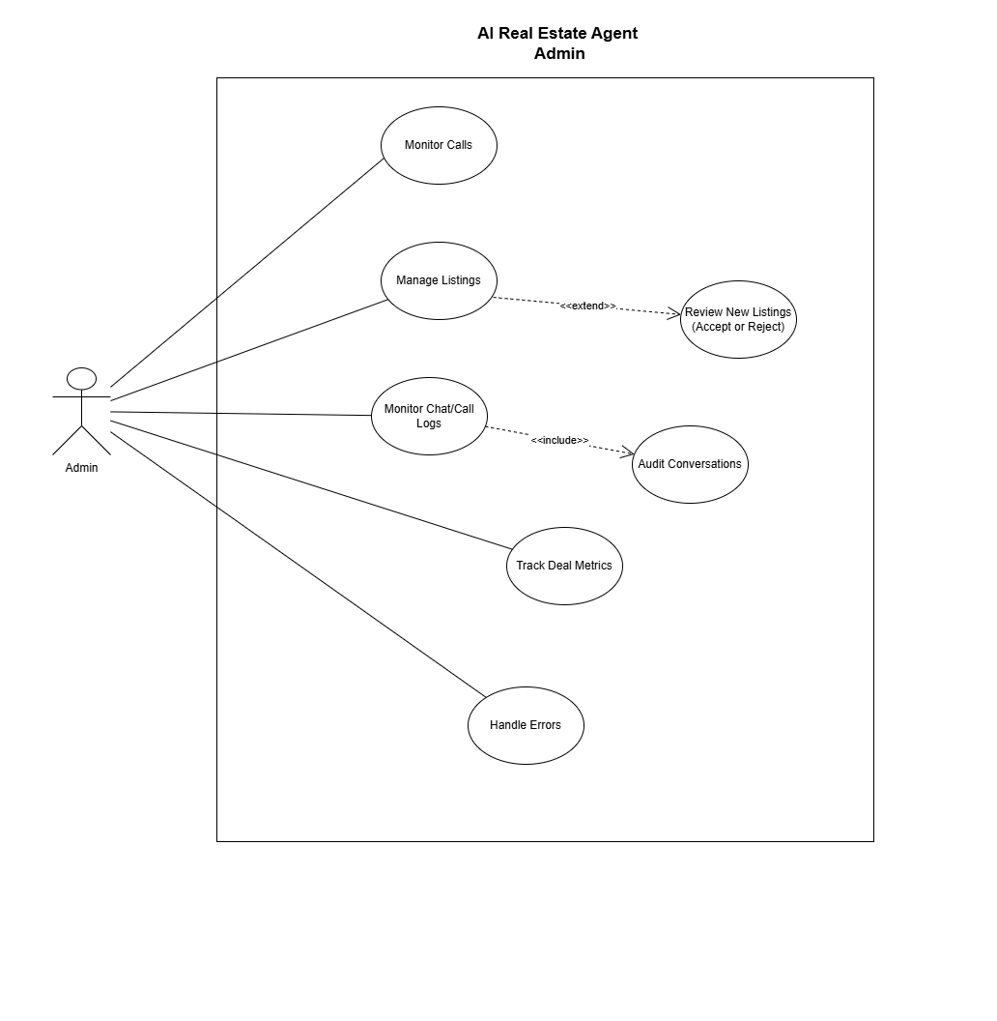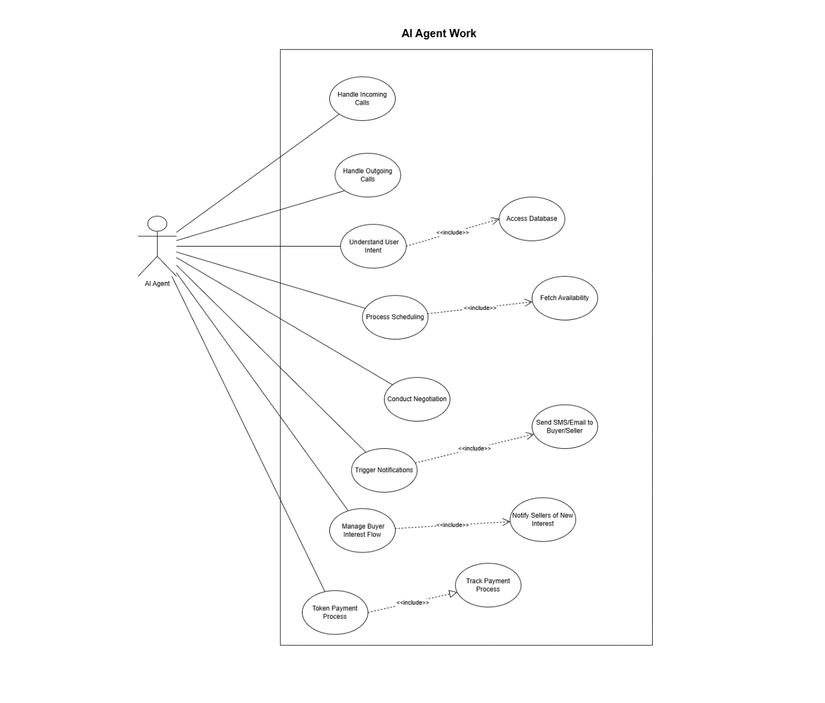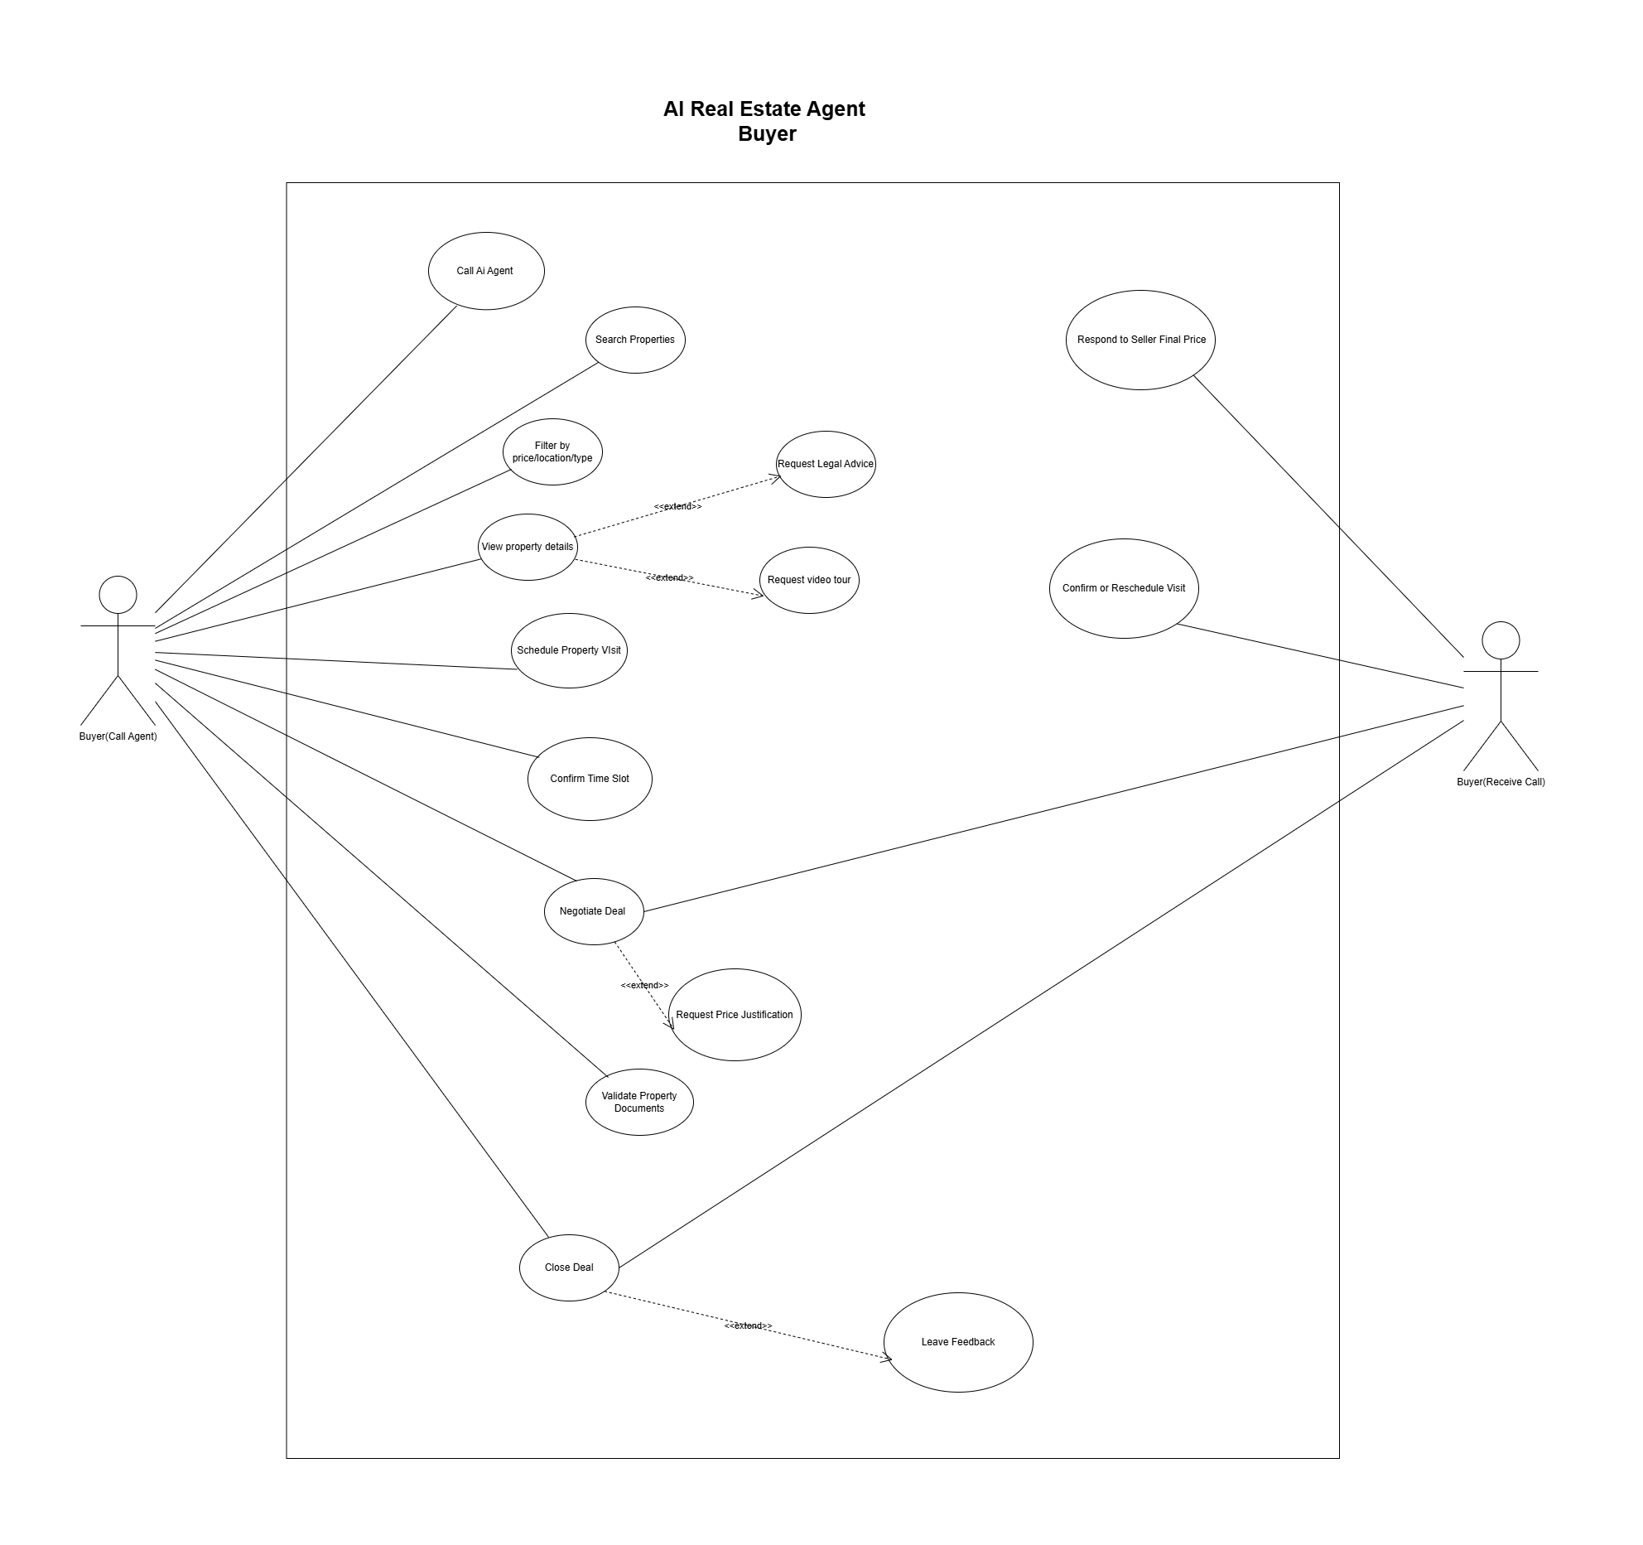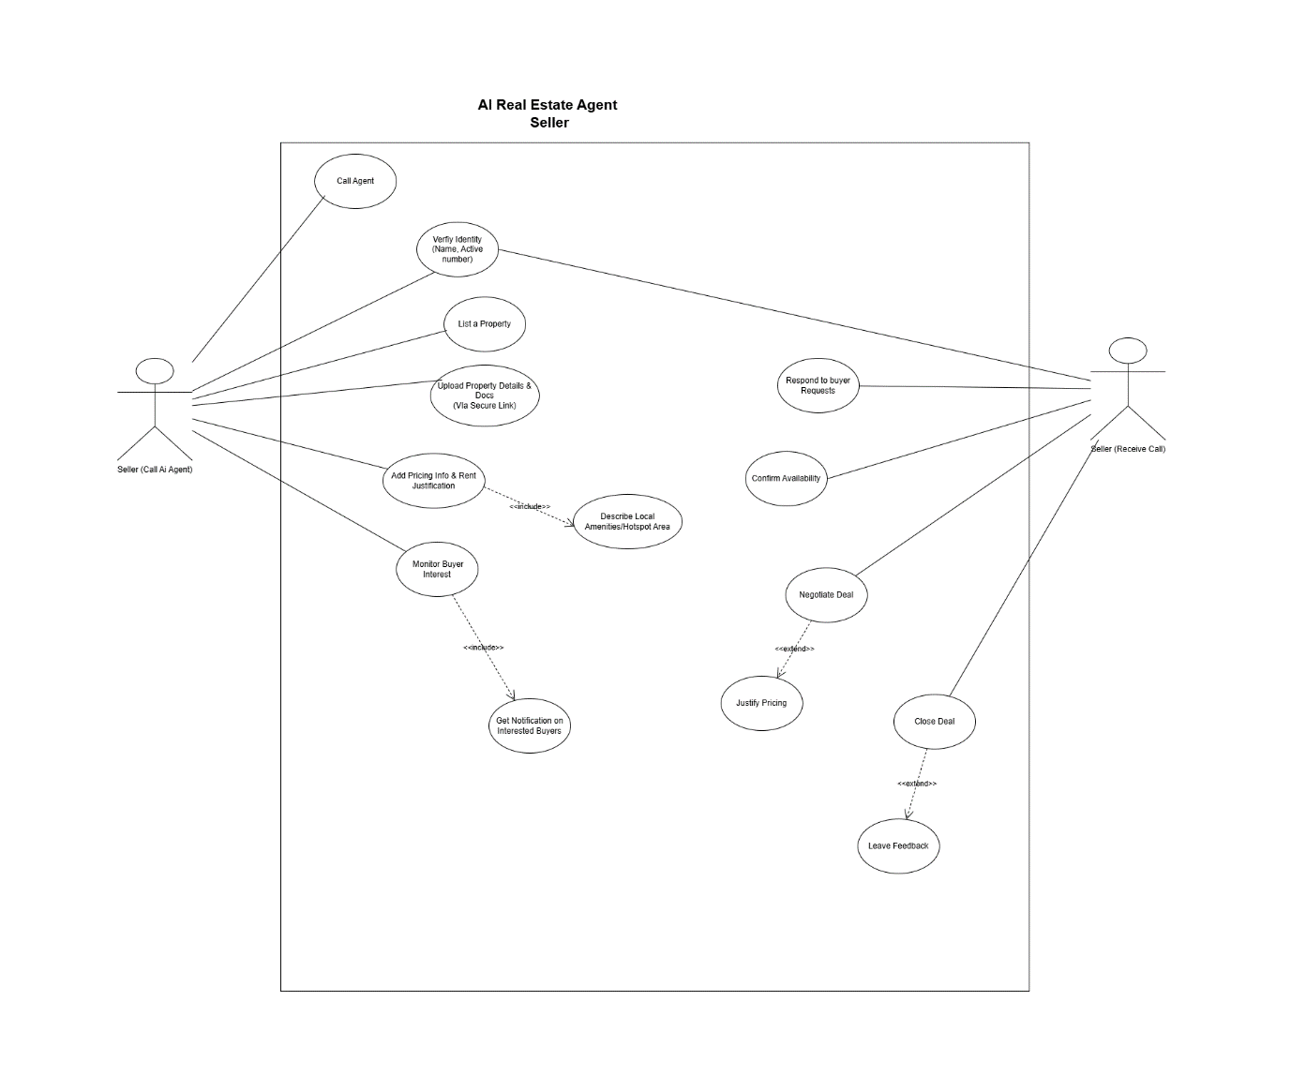

**AI Agent Test Case:**

|  |  |  |  |  |
| --- | --- | --- | --- | --- |
| Test Case ID | Description | Input | Expected Output | Actual Result |
| TC01 | Buyer calls and requests property info | Voice: 'Show me apartments in NY' | AI lists available properties in New York | Pass |
| TC02 | Seller lists new property | Voice: 'I want to list my house' | AI prompts for property details and confirms | Pass |
| TC03 | AI schedules a property visit | Voice: 'Book a visit on Friday' | AI checks availability and schedules the visit | Pass |
| TC04 | Token payment confirmation | Voice: 'I want to confirm payment' | AI sends payment link and confirms token | Pass |

**AI Real Estate Agent : Buyer**

**Buyer Call Agent:**

1. Ai ask for want to buy property or list a property.

|  |  |
| --- | --- |
| **If buyer then** | **If seller then** |
| Proceed with buyer steps | Proceed with seller steps |

1. Buyer Ask for properties(AI respond to where , budget etc.)
2. Filter the price, budget, location etc.

|  |  |  |
| --- | --- | --- |
| **If property avail** | **If property is avail in this location but not price** | **If not avail** |
| Then proceed to step | Tells the buyer to increase budget | Tell the buyer no property avail but i can show you the better area. |

1. AI respond to buyer with property details like there is the place, that’s the price etc.

|  |  |
| --- | --- |
| **IF buyer ask for** | **ELSE IF buyer didn’t ask for** |
| AI give legal advice or video tour  (Via sms) | Process to scheduling |

1. Buyer selects the property and schedule the property visit like he is free on Sunday.
2. The Ai checks the database if seller gives him the time when he is free.

|  |  |  |
| --- | --- | --- |
| **IF time matches** | **Else if time didn’t match** | **Else if the seller didn’t give him anytime when listing property** |
| Ai confirm buyer with time slot**(check database)** | Call the seller if he can do that . | Call the seller to get time. |

1. Buyer confirms the time slot.
2. Then negotiation.

|  |  |  |  |
| --- | --- | --- | --- |
| **If buyer likes the offer the Ai gave** | **If buyer ask for price justification** | **If buyer gave his offer that is close** | **If buyer gave offer that is not close** |
| Then proceeds to next step. | Ai respond to tell him the hotspot area, why price is like this . | Ai calls the Seller to ask. | Ai respond with sorry. |

1. Buyer ask for property documents.

**Then Buyer receive call from Ai Agent**

Agent tell him the final offer of seller

|  |  |  |
| --- | --- | --- |
| **If accepted** | **If rejected** | **First ask for more property** |
| Then close deal | Then start from first point  (After asking) | If yes then show more property. |
| Confirm the time slot or reschedule |  | If no then ask for feedback |

1. Close deal
2. Ask for feedback (if he gave ).

**If buyer feels bored at any point like while closing deal or negotiating**

|  |  |
| --- | --- |
| If yes then | If no then |
| Make a joke | Proceeds with steps |

**AI Real Estate Agent : Seller**

**Seller calls the Ai agent:**

1. Ai ask want to buy property or list a property.

|  |  |
| --- | --- |
| **If buyer then** | **If seller then** |
| Proceed with buyer steps | Proceed with seller steps |

1. Verify his identity like Ai ask for his name , number .
2. Ai start asking what type of property, where.
3. Ai send a SMS with secure link where the seller can upload his property video
4. Then Ai ask about the price , rent.
5. Then ask for hotspot area (justify price because buyer will ask).
6. AI ask for time which time he will be available like Sunday.

|  |  |
| --- | --- |
| **If seller tells him** | **If seller tells him it depends** |
| Save to database | Then proceeds to next step |

1. Then AI respond with listed msg.
2. Then the seller waits for buyer interest.

**AI calls the seller:**

1. Tells him the buyers offer and time.

|  |  |  |  |
| --- | --- | --- | --- |
| **If seller accepts the price and time** | **If seller accepts price but not time** | **If seller accepts time but not price** | **If seller did not accept both** |
| Close deal | Reschedule(Call buyer ) | Call buyer with his final offer. | Call buyer to tell the seller’s offer and time |

1. Close deal
2. AI ask for feedback (optional).

**AI Real Estate Agent : Admin**

1. Monitor calls.
2. Manage listings ( Can reject if the fake )
3. Check for frauds.
4. Block those who didn’t come after confirming.
5. Check call recordings
6. Always save the data
7. Track deal. To avoid his percentage scam so buyer seller avoid it.
8. Handle AI agent error.

**AI Real Estate Agent : Agent**

1. Handle Incoming calls.
2. Handle outgoing calls.
3. Understand user saying’s .
4. Process scheduling like buyer tells the time then call seller both confirm then scheduled .
5. Conduct negotiation so both sides will be happy.
6. Trigger notifications like successfully listed , time , price etc.
7. Manage buyer interest like check his filters.
8. Token payment process to avoid scams.
9. Token payment will conduct via secure sms link.

**Conclusion**

* 1. **Deliverables**:
* Fully functional AI Call Agent for real estate.
* Admin panel to manage listings, logs, and AI behavior.
* Buyer/Seller interaction reports and negotiation tracking.
  1. **Process Benefits**:
* 24/7 automated property support and communication.
* Fast negotiation and deal closures via AI.
* Scalable, low-cost alternative to human agents.
  1. **Quality Tools Used**:
* **Speech-to-Text & NLP**: Google / OpenAI Whisper.
* **Database**: Firebase / MongoDB.
* **Monitoring**: Admin dashboard & call logs.
* **Testing**: Manual test cases & call flow simulations.